

WEB SCRIPTING

CSE – 220 QUARTER V



September 30, 2020

M.Sathishkumar

E0119052

**Challenge 1:**

* Create database

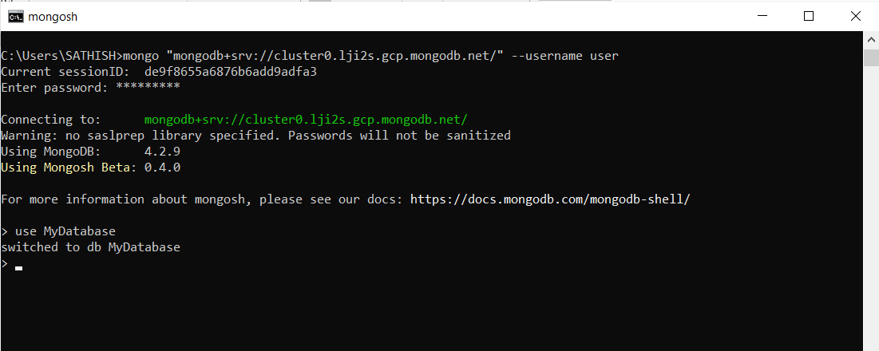

* Show currently selected Database



* Show dbs command before inserting any document inside



* Show dbs command after inserting document inside our db

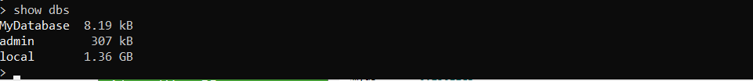

* Creating collections



* Displaying all Collections in Database



* Dropping a collection



* Inserting a document in collection using InsertOne



* Inserting a document in collection using InsertMany

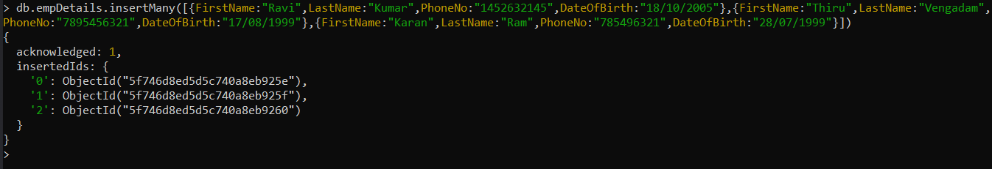

* Retrive All documents from collections

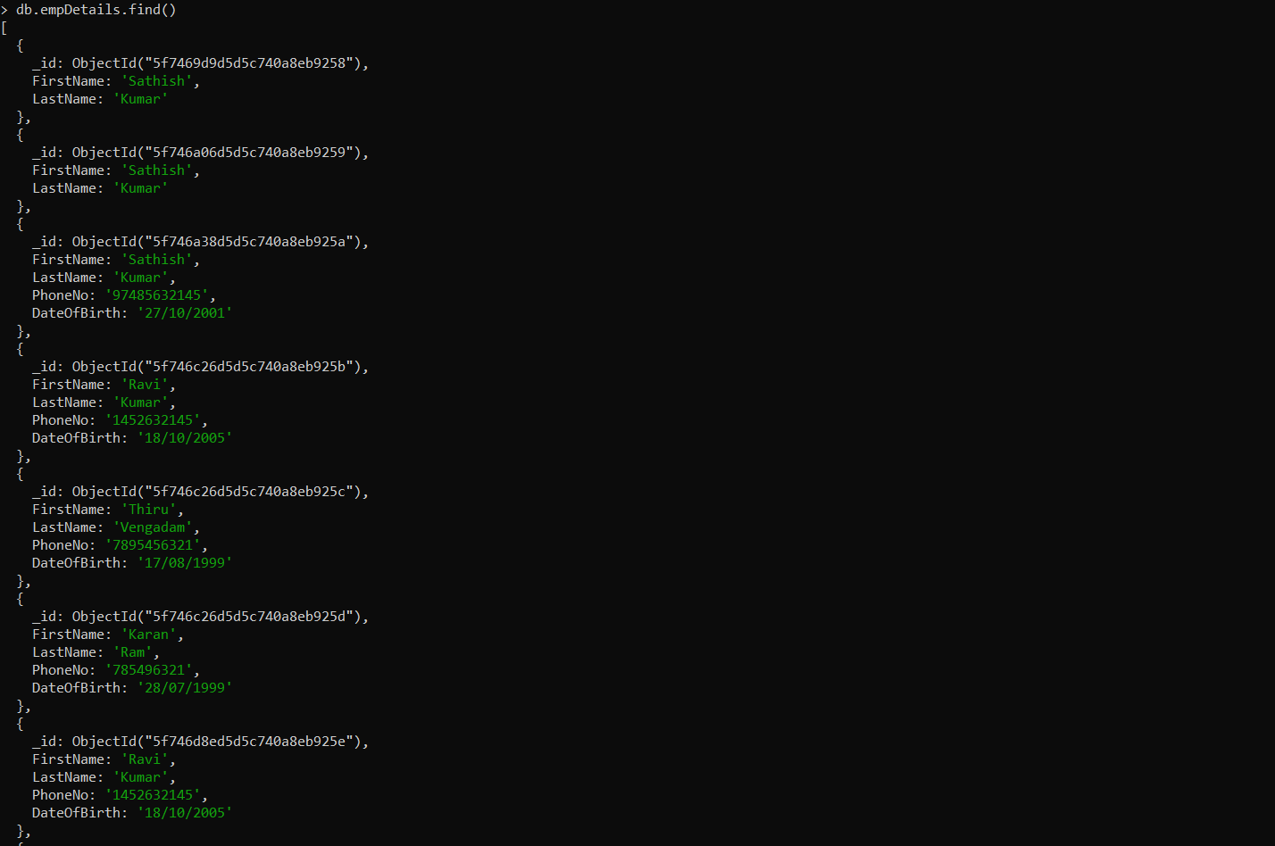

* Searching for required document



* Retrive All documents from collections and arranging in easy reading format

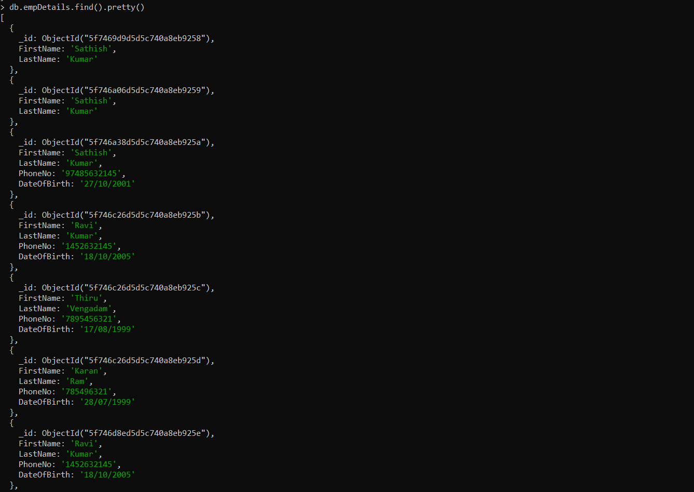

* Using AND condition

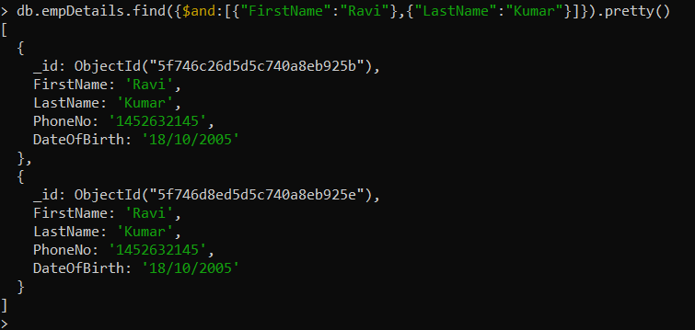

* Updating Data

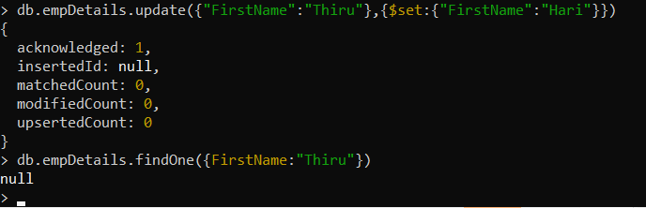

**Challenge 2:**

Connecting MongoDB With NodeJS

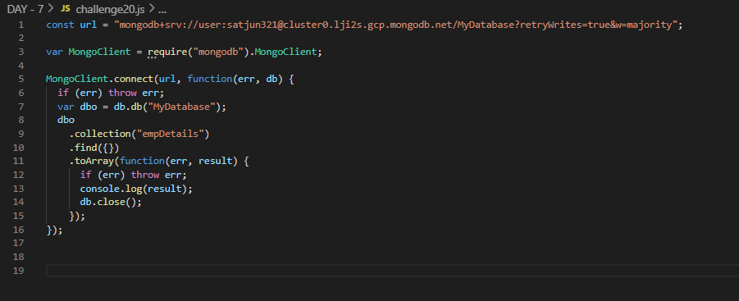

Output:

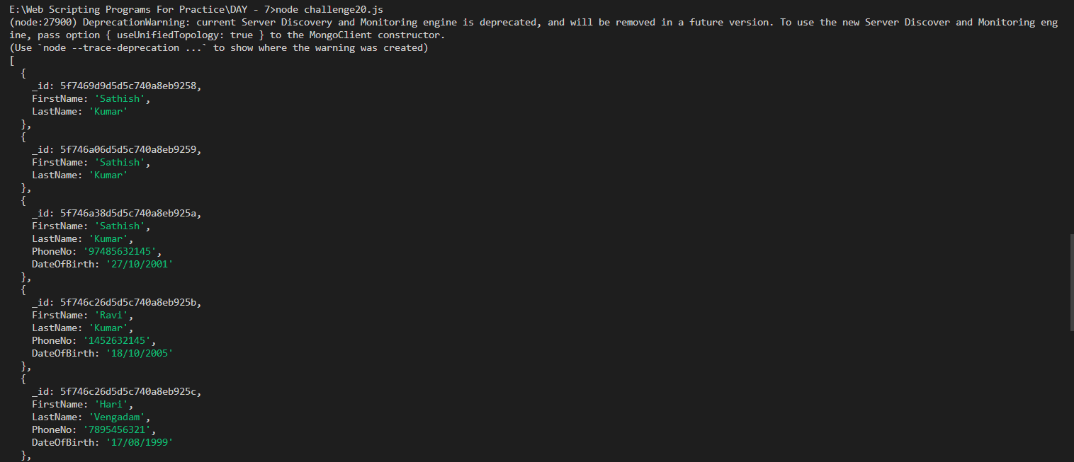

Connecting MongoDB With NodeJS and creating a collection with already existing collections name

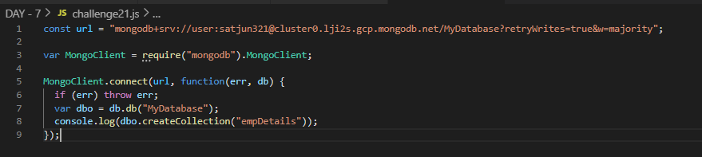

Output:

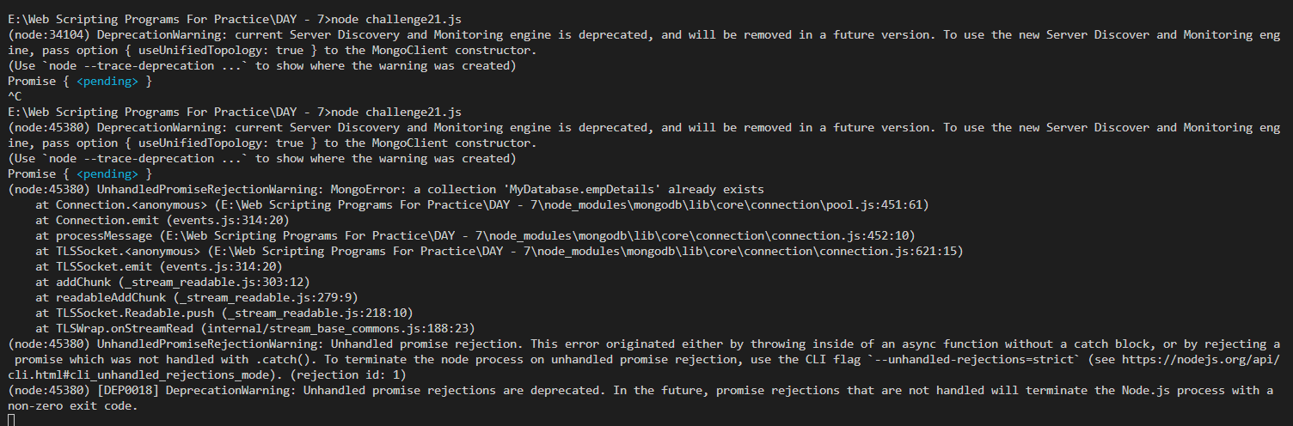

* Error on creating a collection with same name as existing collection name.
* MONGO DB doesn’t allow creating multiple collections with same name